NAvigation

The purposes and goals of the game navigation system differs from on-foot and in-vehicle control. Similarities though between these systems exist as well.

Proposed are two Navigational Systems, a Navigational Radar and In-World Navigation system.

The purpose of Navigation….
- Clearly identify the location of where your current goal is (person, place, object)
- Should be done as a way-point system as our intention is to give the more specific direction – the should still have choice
- Indicate Position of opponent(s)
- Indicate relative proximity to your goal
Goals of navigation are …
- Take up minimum screen real estate
- Could be an in-game element or on the HUD
- Not hamper gameplay
- Be clear and easy to understand
- Icon based, not text based (localization)
- Content
- Add energy, eye candy
- Indicates when the player is traveling in the direction opposite to the general direction in which the current objective requires (dialogue?)

In-WORLD Navigation System

- This system is only engaged in missions
- This system will appear both when in-vehicle and on-foot
- It’s only engaged when there is a specific point that the user is directed towards (e.g., the next collectible, locator, NPC, waypoint, etc.)
- Throughout the world on key intersections Animated Navigational arrows will appear. The arrows point in the general direction of the player’s current objective. All intersections are flat, so a common in-game animation can be used, e.g.:

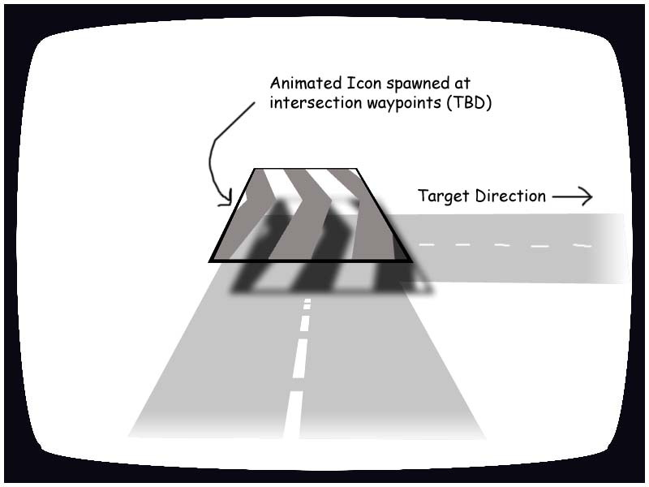

- The road data will include data on whether a path is a shortcut, and which intersections should show the animation
- There may be many intersections between the player and their objective. So the algorithm will include something like the following steps:
  - Find the road piece nearest to the user character
  - Find the road piece nearest to the destination point
  - Traverse the level in both directions to find the shortest [non-shortcut] path between these pieces of road
  - Mark the intersections with a directional animation
  - Mark at least one intersection in “the wrong way” from the shortest route. E.g., if you are directed to the Kwik-E-Mart and turn right out of the Simpson’s driveway, you would realize you are going the wrong way when you hit the next intersection

The player can turn this function off in the pause menu (Options - Settings - Intersection Navigation System on/off).

HUD Radar

For specific mission objective a HUD Radar element will appear in the bottom right hand corner. The purpose of this HUD is to relatively indicate mission objectives. These objectives include…

- Opponent locations, and proximity
- Character locations and proximity
- Collectables location and proximity

The design of the Radar element should be subtle and transparent. Specific icons should be investigated to represent objectives….

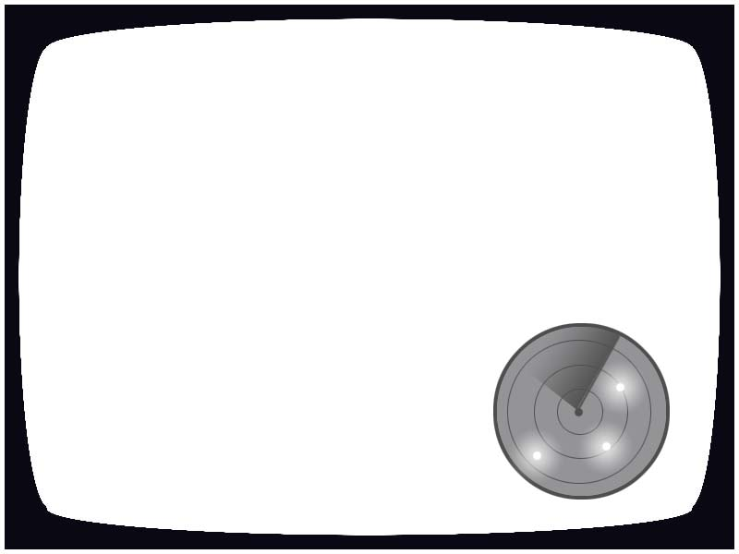

Icon types, colors and design need to be addressed. An added functionality of a large

*Lard Lad icon appearing when a player is close to a lard lad (Austin Powers reference) should be incorporated.

HUD Radar - functions

General…
- No auto-zoom – the zoom distance won’t ever change; as a 1st pass it should show an area up to approximately 150m from the player

On-Foot…
- The HUD radar generally will not appear in Virtual Springfield mode
- The HUD Radar will only appear in Virtual Springfield mode when the player is within the radar radius of the next mission start location.

In-Vehicles…
- The HUD Radar will appear when dictated by the mission type
- In missions the radar shows:
  - The relative position and orientation of AI vehicles (as now, with triangular icons)
  - Harassment vehicles (the cops) are visually different than regular AI vehicles (e.g., the harass icons flash or pulse)
  - The next collectible or key location is shown as a dot
- AI vehicles that are off the range of the radar will be drawn on the edge of it
- Collectibles or locations off the range of the map are not drawn

Note: This feature should not be checked into the game until the road-based navigation system is implemented.

HUD Radar - Art Design
- Monochrome (futuristic) blue radar?
- Includes animated radar-sweep
- Icons glow or pulse when hit by radar sweep
- Fade in/out when taken on and off the screen?

